FOSSIL-Keichousaurus Turtle Fossil

**Name: Manchurochelys liaoxiensis  
  
Geologic Age: Cretaceous  
  
Location: Liaoning's Yixian Formation, China**

**Size: 8*150MM*200MM**

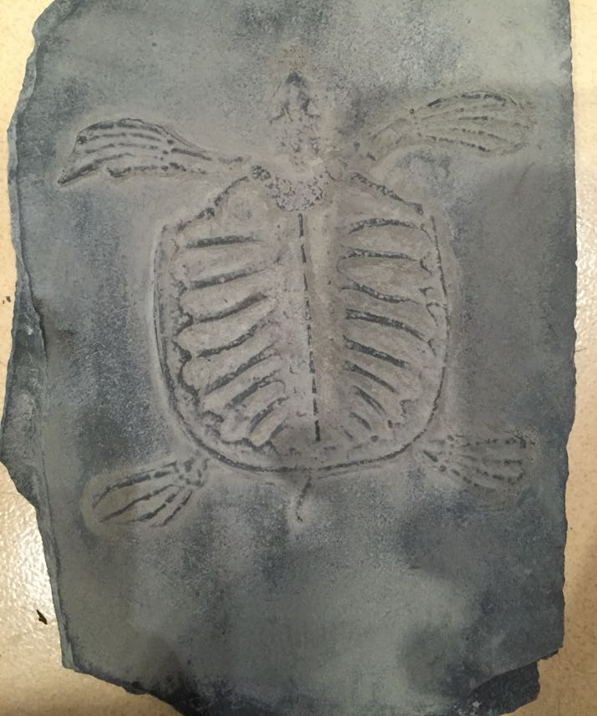 **Comments: Manchurochelys liaoxiensis, also known as Ordosemys liaoxiensis, is described as a cryptodire (a turtle order), with a very low domed shell. It is an extinct genus of turtle in the order Paracryptodira. It existed during the early Cretaceous of what is now northeast China. It has been found in the Jianshangou Bed of West Liaoning's Yixian Formation. However, it is a rarely found fossil. The carapace, shell, had an oval outline, with the length being slightly longer than the width. Manchurochelys liaoxiensis looked like a modern turtle, but it was a primitive turtle and could not draw its head or legs into its shell. It likely fed on plants, small fish, and insects present in its environment. Manchurochelys liaoxiensis is most closely related to today's snapping turtle. The Liaoning region, 130 million years ago, was an area crossed by streams and rivers and dotted with fresh water lakes and active volcanoes. The land areas were covered by forests of conifers, similar to today's pine and fir, ginkgoes and ferns. There were very few angiosperms, flowering plants. Marshy areas surrounded the lakes. Based on the plants represented in the fossil record of the area, it suggests that the area around Liaoning was a semiarid environment with a warm but dry climate.**